GHS Symboler

 | Beskrivning | Symbol
GHS01-50  GHS01-100 | GHS Exploderande ämnen  50 mm x 25 m  100 mm x 25 m | 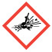
GHS01-50  GHS02-100 | GHS Brandfarligt  50 mm x 25 m  100 mm x 25 m | 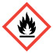
GHS03-50  GHS03-100 | GHS Oxiderande  50mm x 25 m  100 mm x 25 m | 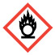
GHS04-50  GHS04-100 | GHS Gas under tryck  50mm x 25 m  100 mm x 25 m | 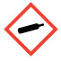
GHS05-50  GHS05-100 | GHS Frätande  50mm x 25 m  100 mm x 25 m | 
GHS06-50  GHS06-100 | GHS Giftigt  50 mm x 25 m  100mm x 25 m | 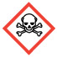
GHS07-50  GHS07-100 | GHS Skadliga ämnen  50mm x 25 m  100 mm x 25 m | 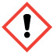
GHS08-50  GHS08-100 | GHS Hälsofarlig  50mm x 25 m  100 mm x 25 m | 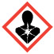
GHS09-50  GHS09-100 | GHS Miljöfarligt  50mm x 25 m  100 mm x 25 m | 